## Reports Menu/Pharmacist Report/Input - Incorrect Entries:

Request:

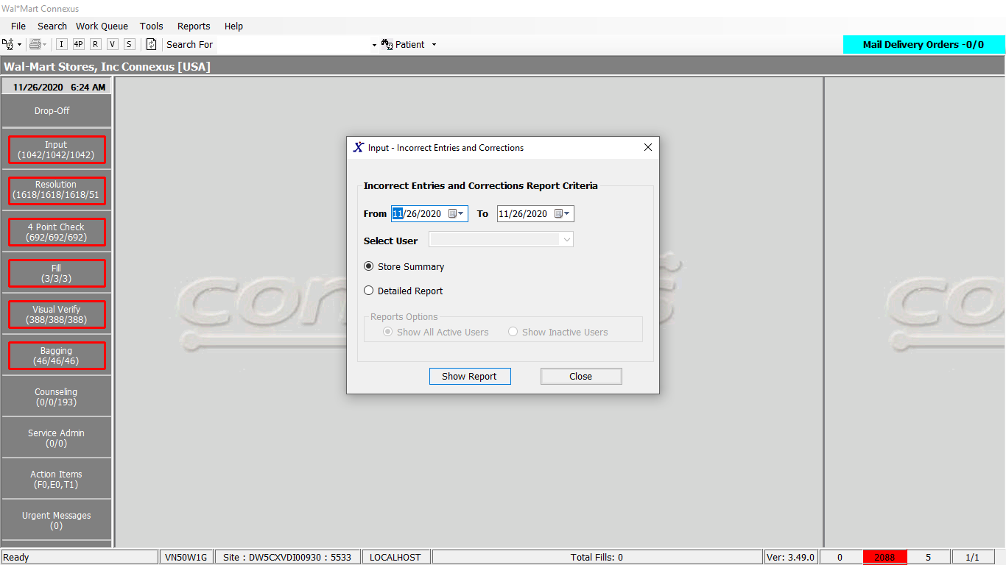

Response:

Summary Report:

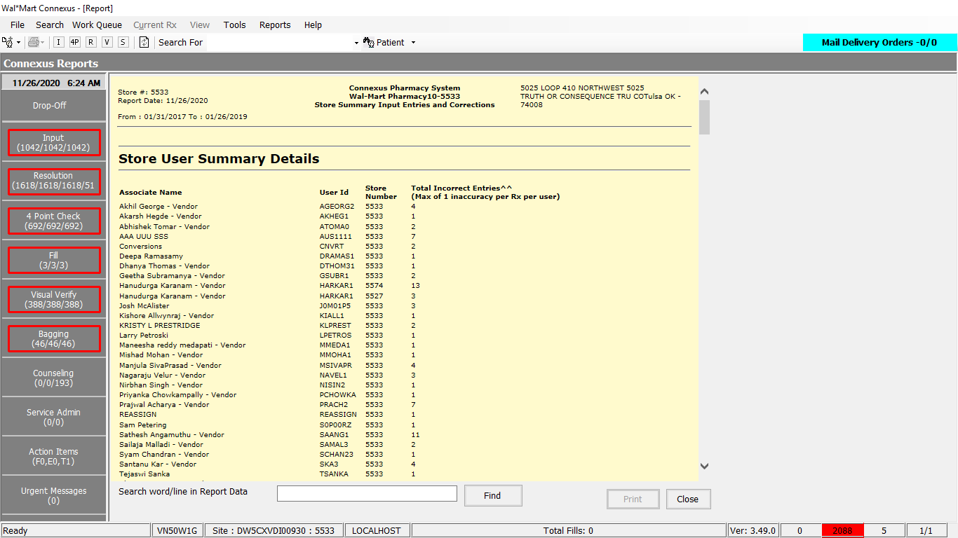

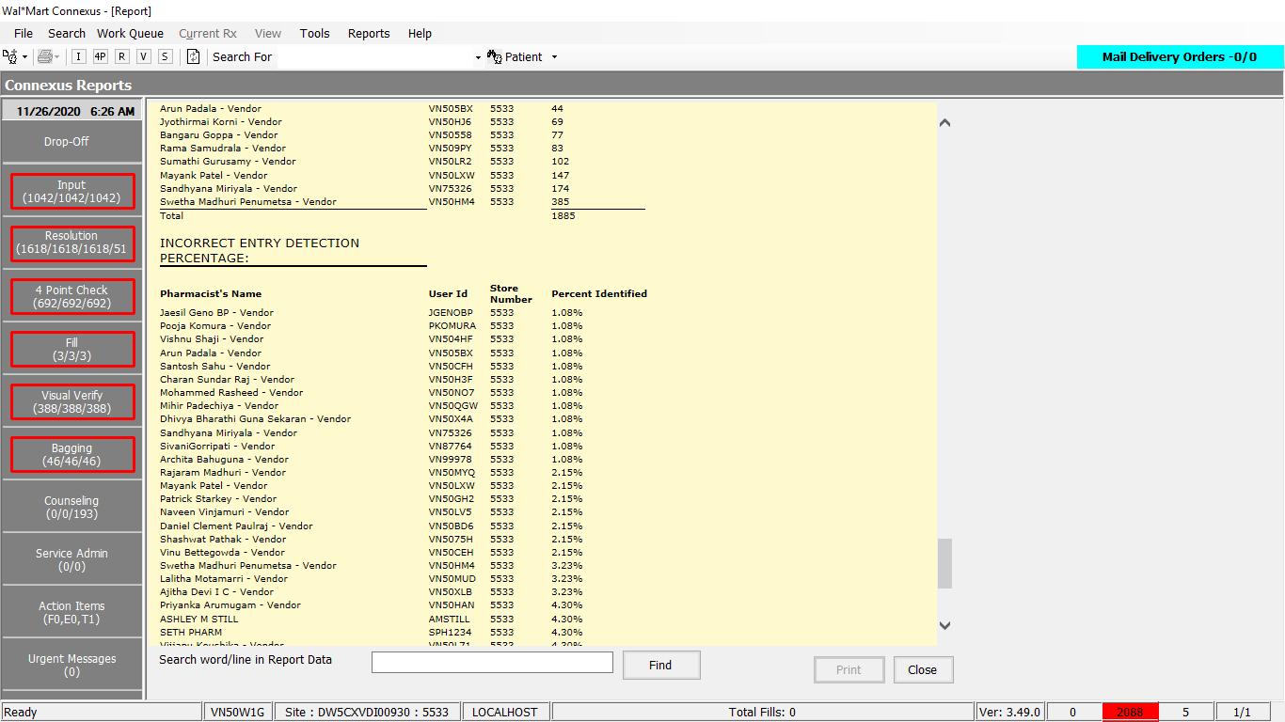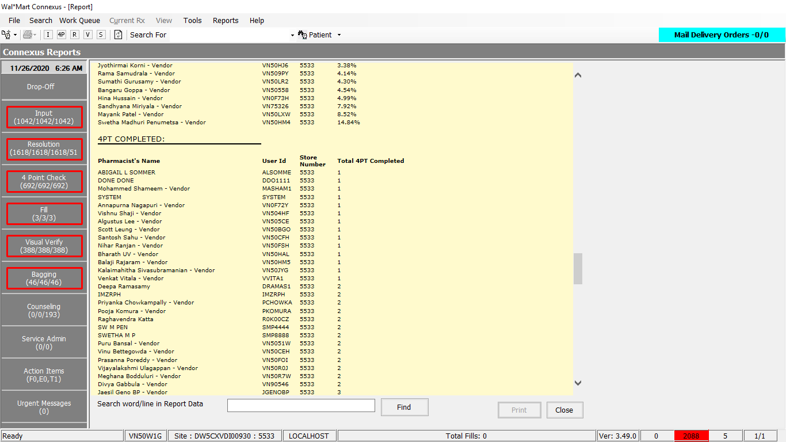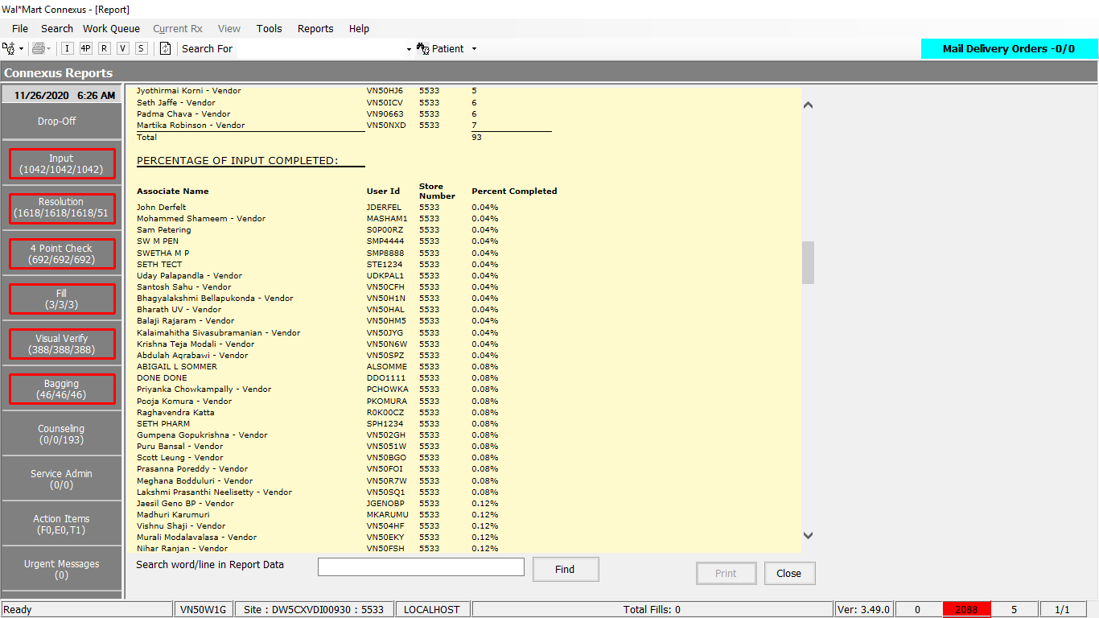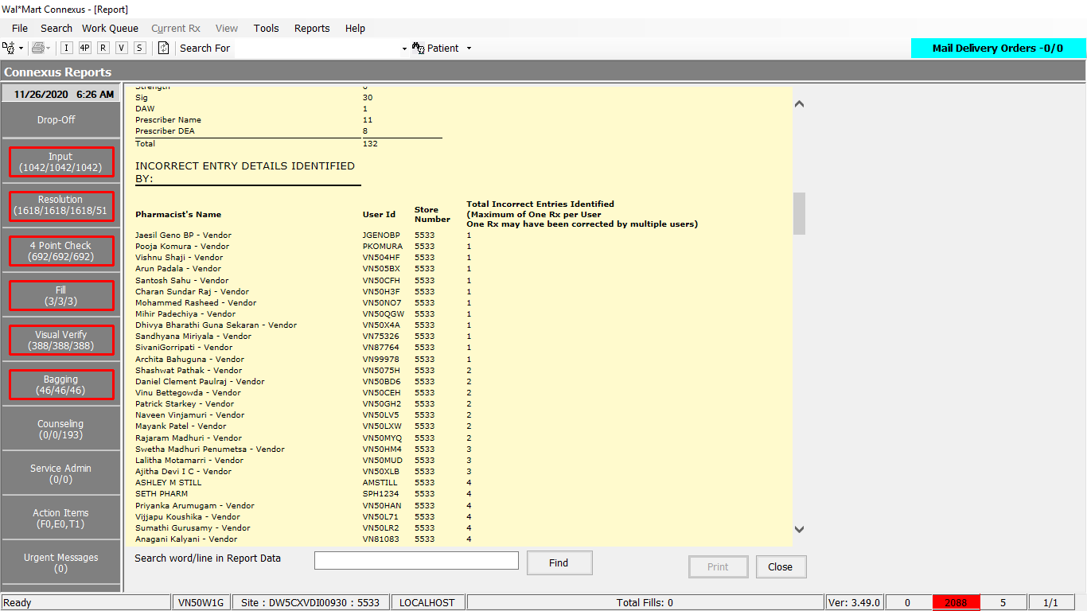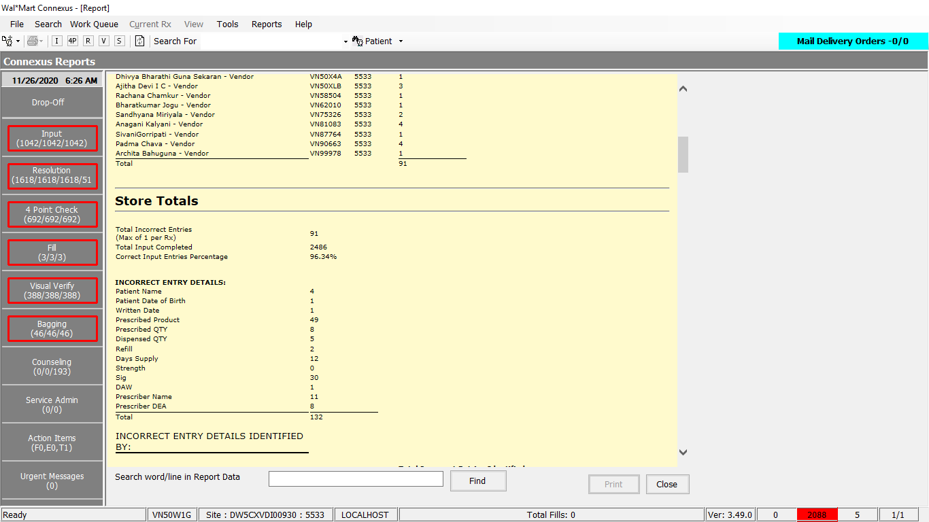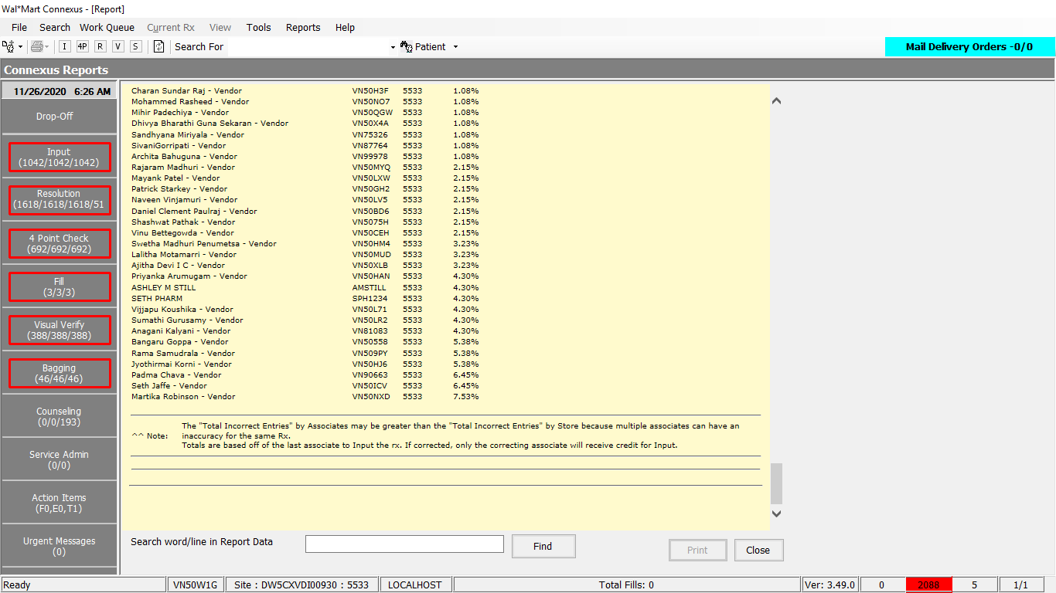

Detailed Report:

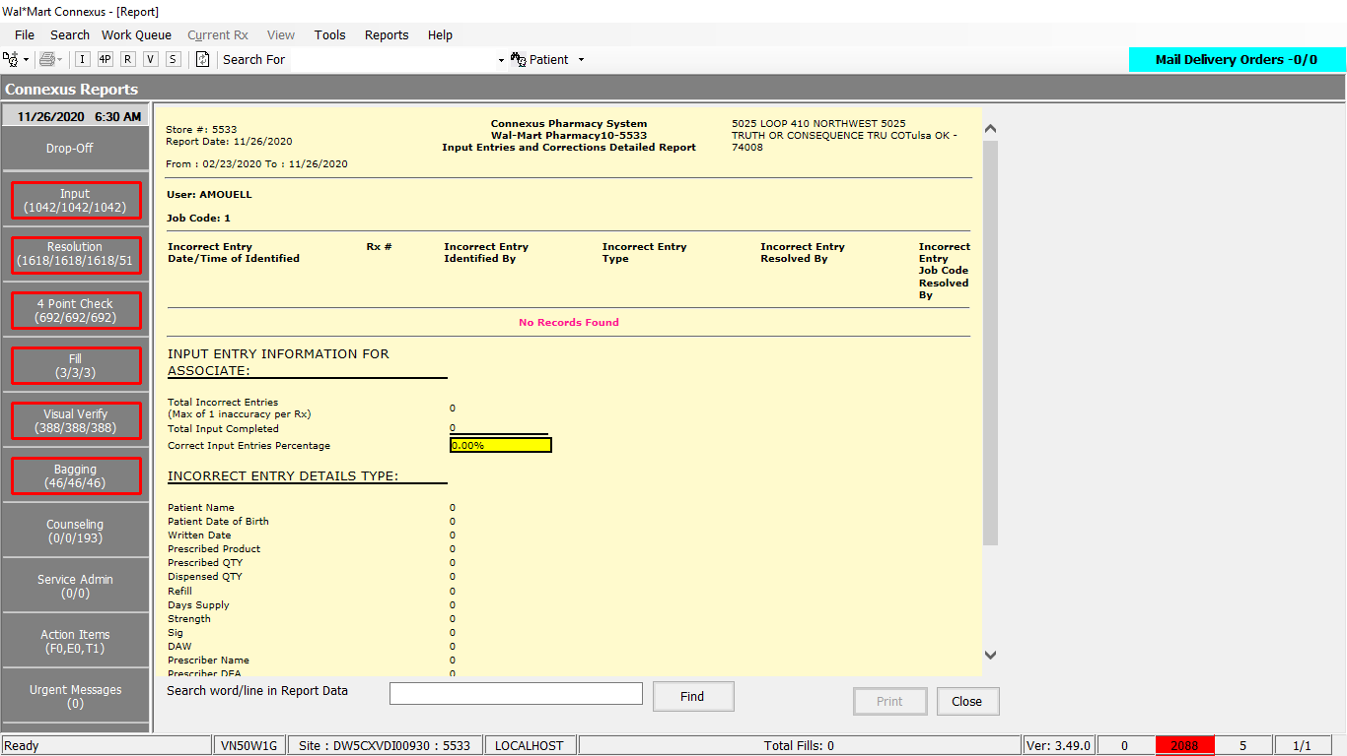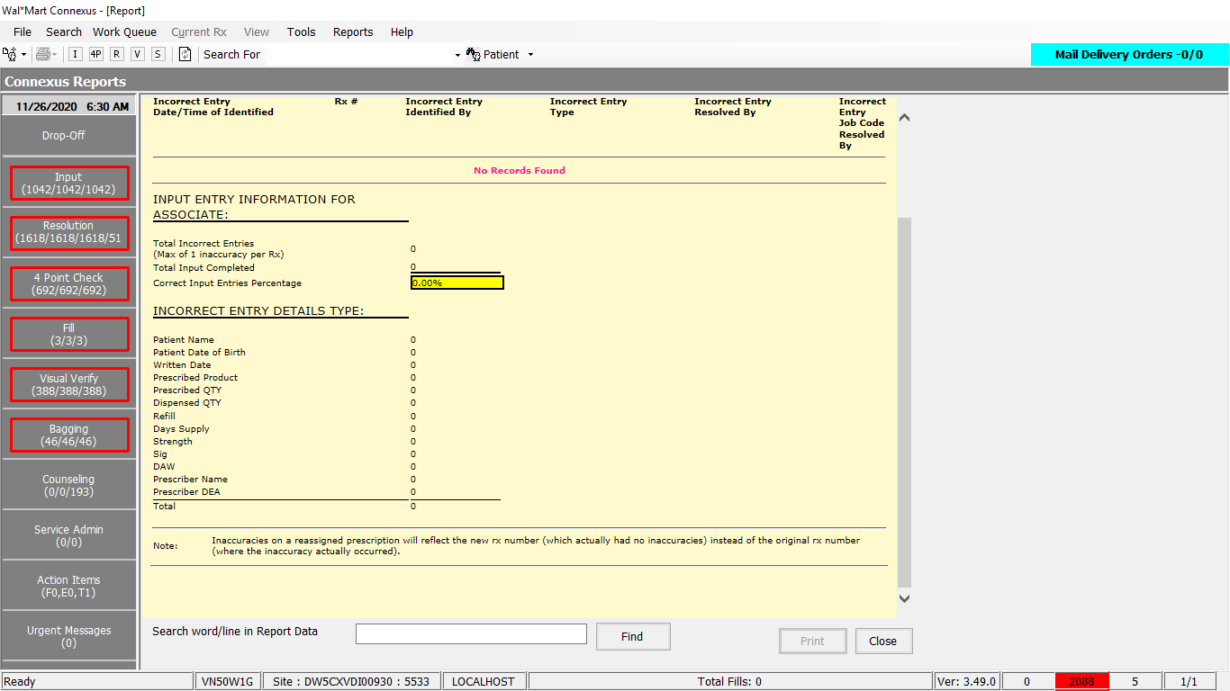

Queries:

Friend Const GetUserCorrectionDetailedUserInfo As String = " SELECT rx.rx_nbr rx_nbr, EXTEND(aa.activity_ts, YEAR TO MINUTE) activity_ts, atask.task_desc task_desc, " &

" (TRIM(a1.audit_userid) || '.s0' || DECODE(NVL(a1.user_store_nbr, 0), 0, (SELECT phm_bu_id FROM rx21c:pharmacy_bu), a1.user_store_nbr)) identify_user, " &

" (TRIM(a2.audit_userid) || '.s0' || DECODE(NVL(a2.user_store_nbr, 0), 0, (SELECT phm_bu_id FROM rx21c:pharmacy_bu), a2.user_store_nbr)) resolve_user, " &

" DECODE(su.security_level, 1, 'RPH', 'Non RPH') resolve_user_role " &

" FROM error_and_audit:appl_activity aa, rx21c:rx rx, error_and_audit:appl_actv_subject aas, error_and_audit:audit a3, " &

" error_and_audit:appl_task atask, " &

" error_and_audit:audit a1, " &

" OUTER (error_and_audit:audit a2,phm_appl_security:system_user su) " &

" WHERE a3.activity_id = aa.activity_id " &

" AND a3.audit_type_code = ? " &

" AND UPPER(a3.audit_userid) = UPPER(?) " &

" AND DATE(aa.activity_ts) >= ? AND DATE(aa.activity_ts) <= ? " &

" AND rx.rx_id = aas.subject_id " &

" AND aas.subject_type_code = 314 " &

" AND aas.activity_id = aa.activity_id " &

" AND aa.task_id = atask.task_id " &

" AND a1.activity_id = aa.activity_id " &

" AND a1.audit_type_code = ? " &

" AND a2.activity_id = aa.activity_id " &

" AND a2.audit_type_code = ? " &

" AND (DATE(su.revoke_date) >= ? OR su.revoke_date IS NULL) " &

" AND UPPER(a2.audit_userid) = UPPER(su.userid) "

2. Friend Const GetUserCorrTotalCountsForUser As String = "SELECT COUNT(UNIQUE rx.rx_nbr) total_count, '100' section_type " &

" FROM rx21c:rx rx, " &

" error_and_audit:appl_activity aa, " &

" error_and_audit:audit a3, " &

" error_and_audit:appl_actv_subject aas " &

" WHERE rx.rx_id = aas.subject_id " &

" AND aas.subject_type_code = 314 " &

" AND aas.activity_id = aa.activity_id " &

" AND a3.activity_id = aa.activity_id " &

" AND a3.audit_type_code = ? " &

" AND DATE(aa.activity_ts) >= ? AND DATE(aa.activity_ts) <= ? " &

" AND UPPER(a3.audit_userid) = UPPER(?) " &

" UNION " &

"SELECT COUNT(UNIQUE ra.rx_id) total_count, '200' section_type " &

" FROM rx21c:rx_activity ra " &

" WHERE ra.activity_code = 32620 " &

" AND DATE(ra.activity_ts) >= ? AND DATE(ra.activity_ts) <= ? " &

" AND UPPER(ra.activity_userid) = UPPER(?) "

Friend Const GetUserCorrCountsByUser As String = "SELECT count(a1.audit_id) total_count, atask.task_desc task_desc, atask.task_id task_id " &

" FROM error_and_audit:appl_activity aa, " &

" error_and_audit:audit a1, " &

" error_and_audit:appl_task atask " &

" WHERE aa.task_id = atask.task_id " &

" AND a1.activity_id = aa.activity_id " &

" AND a1.audit_type_code = ? " &

" AND UPPER(a1.audit_userid) = UPPER(?) " &

" AND DATE(aa.activity_ts) >= ? AND DATE(aa.activity_ts) <= ? " &

" GROUP BY 2,3 ORDER BY 2 "

Friend Const GetUserCorr4ptCountsByUser As String =

" SELECT count(UNIQUE rx.rx_nbr) total_count, a2.audit_userid user_id, " &

" DECODE(NVL(a2.user_store_nbr, " &

" 0), 0, ( " &

" SELECT phm_bu_id " &

" FROM rx21c:pharmacy_bu), a2.user_store_nbr) user_store, " &

" NVL(su.user_descr,a2.audit_userid) user_desc , " &

" '100' type_rpt " &

" FROM error_and_audit:appl_activity aa, " &

" error_and_audit:audit a1, " &

" error_and_audit:audit a2, " &

" error_and_audit:appl_actv_subject aas,rx21c:rx rx, OUTER(phm_appl_security:system_user su ) " &

" WHERE rx.rx_id = aas.subject_id " &

" AND aas.subject_type_code = 314 " &

" AND aas.activity_id = aa.activity_id " &

" AND a2.activity_id = aa.activity_id " &

" AND a1.audit_type_code = ? " &

" AND UPPER(a1.audit_userid)=UPPER(?) and a1.activity_id=a2.activity_id and a2.audit_type_code =? " &

" AND UPPER(su.userid) = UPPER(a2.audit_userid) " &

" AND (DATE(su.revoke_date) >= ? OR su.revoke_date IS NULL) " &

" AND DATE(aa.activity_ts) >= ? AND DATE(aa.activity_ts) <= ? " &

" GROUP BY 2,3,4 " &

" UNION " &

" SELECT COUNT(UNIQUE ra2.rx_id) total_count, ra2.activity_userid user_id, " &

" NVL(ra2.activity_store_nbr, (" &

" SELECT phm_bu_id " &

" FROM rx21c:pharmacy_bu)) user_store, NVL(su1.user_descr, ra2.activity_userid) user_desc, " &

" '200' type_rpt FROM rx21c:rx_activity ra2, OUTER(phm_appl_security:system_user su1),rx21c:rx rx2 " &

" WHERE ra2.activity_code = 1103 " &

" AND DATE(ra2.activity_ts) >= ? " &

" AND DATE(ra2.activity_ts) <= ? " &

" AND (DATE(su1.revoke_date) >= ? OR su1.revoke_date IS NULL) " &

" AND UPPER(ra2.activity_userid) = UPPER(su1.userid) " &

" AND ra2.rx_id = rx2.rx_id " &

" AND UPPER(rx2.rx_entry_userid) = UPPER(?) " &

" AND NVL(ra2.activity_store_nbr,( " &

" SELECT phm_bu_id " &

" FROM rx21c:pharmacy_bu)) = NVL(su1.store_nbr,( " &

" SELECT phm_bu_id " &

" FROM rx21c:pharmacy_bu)) " &

" GROUP BY 2,3, 4 "

DAL:

Public Function getUserCorrStoreUserDetailed(ByVal siteId As Integer, ByVal BeginDate As Date, ByVal EndDate As Date, ByVal UserID As String) As List(Of UserCorrectionDetailsBE) Implements IReportDAL.getUserCorrStoreUserDetailed

Using (New Tracer(ConnexusCommonConstants.ConnexusTracer))

Dim response As New List(Of UserCorrectionDetailsBE)

Dim tempStat As UserCorrectionDetailsBE

Dim paramList As New List(Of DbParameter)

paramList.AddParameter(DbType.Int32, AuditTypeCode.Creator, "errorCreator")

paramList.AddParameter(DbType.String, UserID, "userID")

paramList.AddParameter(DbType.Date, BeginDate, "startDate")

paramList.AddParameter(DbType.Date, EndDate, "endDate")

paramList.AddParameter(DbType.Int32, AuditTypeCode.Identifier, "identifyUser")

paramList.AddParameter(DbType.Int32, AuditTypeCode.Resolver, "resolveUser")

paramList.AddParameter(DbType.Date, BeginDate, "startDate1")

Using dr As IDataReader = ExecuteReader(DatabaseEnum.Error_And_Audit, siteId, ReportQueries.GetUserCorrectionDetailedUserInfo, paramList)

While dr.Read()

tempStat = New UserCorrectionDetailsBE

tempStat.RxNumber = (dr.GetValueOrDefault(Of Int32)("rx_nbr"))

tempStat.TimeStamp = (dr.GetValueOrDefault(Of DateTime)("activity_ts"))

tempStat.EntryTypeDesc = (dr.GetValueOrDefault(Of String)("task_desc"))

tempStat.IdentifyUser = (dr.GetValueOrDefault(Of String)("identify_user"))

tempStat.CorrectingUser = (dr.GetValueOrDefault(Of String)("resolve_user"))

tempStat.CorrectingUserJobDesc = (dr.GetValueOrDefault(Of String)("resolve_user_role"))

response.Add(tempStat)

End While

End Using

Return response

End Using

End Function

Public Function getUserCorrectStoreInfo(ByVal siteId As Integer, ByVal BeginDate As Date, ByVal EndDate As Date, ByVal UserID As String) As UserCorrectionsUserReportBE Implements IReportDAL.getUserCorrectStoreInfo

Using (New Tracer(ConnexusCommonConstants.ConnexusTracer))

Dim response As New UserCorrectionsUserReportBE

Dim tempDec As Decimal

'Get the Total Number Inputted and Errors

Dim paramList As New List(Of DbParameter)

paramList.AddParameter(DbType.Int32, AuditTypeCode.Creator, "errorCreator")

paramList.AddParameter(DbType.Date, BeginDate, "startDate")

paramList.AddParameter(DbType.Date, EndDate, "endDate")

paramList.AddParameter(DbType.String, UserID.ToUpper.Trim, "userID")

paramList.AddParameter(DbType.Date, BeginDate, "startDate1")

paramList.AddParameter(DbType.Date, EndDate, "endDate1")

paramList.AddParameter(DbType.String, UserID.ToUpper.Trim, "userID1")

Dim totalInput As Decimal = 0

Dim totalIncorrect As Decimal = 0

Using dr As IDataReader = ExecuteReader(DatabaseEnum.Error_And_Audit, siteId, ReportQueries.GetUserCorrTotalCountsForUser, paramList)

While dr.Read()

Dim sectionType As String = dr.GetValueOrDefault(Of String)("section_type")

Dim totalCount As Decimal? = dr.GetValueOrDefault(Of Decimal?)("total_count")

If sectionType IsNot Nothing AndAlso totalCount.HasValue Then

If sectionType = "100" Then '100 is Total incorrect entries

totalIncorrect = totalCount.Value

ElseIf sectionType = "200" Then '200 is storeTotal input

totalInput = totalCount.Value

End If

End If

End While

End Using

'Report Needs to Max out at 100%

If totalInput > 0 Then

tempDec = 1 - (totalIncorrect / totalInput)

If tempDec > 1 Then

tempDec = 1

ElseIf tempDec < 0 Then

tempDec = 0

End If

Else

tempDec = 0

End If

response.EntryIncorrectRate = tempDec.ToString("P", CultureInfo.CurrentCulture)

response.IncorrectRX = CInt(totalIncorrect).ToString

response.TotalInputs = CInt(totalInput).ToString

'Get Incorrect Entries by Components

paramList.Clear()

paramList.AddParameter(DbType.Int32, AuditTypeCode.Creator, "errorCreator")

paramList.AddParameter(DbType.String, UserID.ToUpper.Trim, "userID")

paramList.AddParameter(DbType.Date, BeginDate, "startDate")

paramList.AddParameter(DbType.Date, EndDate, "endDate")

response.IncorrectEntryComponents = New CorrectionsComponentsBE

Using dr As IDataReader = ExecuteReader(DatabaseEnum.Error_And_Audit, siteId, ReportQueries.GetUserCorrCountsByUser, paramList)

While dr.Read()

Dim totalCount As Decimal? = dr.GetValueOrDefault(Of Decimal?)("total_count")

Dim taskId As Int32? = dr.GetValueOrDefault(Of Int32?)("task_id")

If totalCount.HasValue AndAlso taskId.HasValue Then

Select Case (dr.GetInt32(dr.GetOrdinal("task_id")))

Case Connexus.Common.Constants.ErrorFields.BirthDate

response.IncorrectEntryComponents.IncorrectPatDOB = Convert.ToInt32(totalCount.Value).ToString

Case Connexus.Common.Constants.ErrorFields.DAW

response.IncorrectEntryComponents.IncorrectDAW = Convert.ToInt32(totalCount.Value).ToString

Case Connexus.Common.Constants.ErrorFields.DayOfSupply

response.IncorrectEntryComponents.IncorrectDaysSupply = Convert.ToInt32(totalCount.Value).ToString

Case Connexus.Common.Constants.ErrorFields.DEANumber

response.IncorrectEntryComponents.IncorrectPrescriberDEA = Convert.ToInt32(totalCount.Value).ToString

Case Connexus.Common.Constants.ErrorFields.DispensedQuantity

response.IncorrectEntryComponents.IncorrectDispenseQty = Convert.ToInt32(totalCount.Value).ToString

Case Connexus.Common.Constants.ErrorFields.PatientName

response.IncorrectEntryComponents.IncorrectPatientName = Convert.ToInt32(totalCount.Value).ToString

Case Connexus.Common.Constants.ErrorFields.PrescribedProduct

response.IncorrectEntryComponents.IncorrectPrescProduct = Convert.ToInt32(totalCount.Value).ToString

Case Connexus.Common.Constants.ErrorFields.PrescribedQuantity

response.IncorrectEntryComponents.IncorrectPrescQty = Convert.ToInt32(totalCount.Value).ToString

Case Connexus.Common.Constants.ErrorFields.Prescriber

response.IncorrectEntryComponents.IncorrectPrescriberName = Convert.ToInt32(totalCount.Value).ToString

Case Connexus.Common.Constants.ErrorFields.Refills

response.IncorrectEntryComponents.IncorrectRefills = Convert.ToInt32(totalCount.Value).ToString

Case Connexus.Common.Constants.ErrorFields.Sig

response.IncorrectEntryComponents.IncorrectSig = Convert.ToInt32(totalCount.Value).ToString

Case Connexus.Common.Constants.ErrorFields.WrittenDate

response.IncorrectEntryComponents.IncorrectWrittenDate = Convert.ToInt32(totalCount.Value).ToString

Case Connexus.Common.Constants.ErrorFields.Strength 'Patient safety - drug strength re-entry

response.IncorrectEntryComponents.IncorrectDrugStrength = Convert.ToInt32(totalCount.Value).ToString

End Select

End If

End While

End Using

'Get 4PT Totals and Indentify Users

paramList.Clear()

paramList.AddParameter(DbType.Int32, AuditTypeCode.Creator, "errorCreator")

paramList.AddParameter(DbType.String, UserID.ToUpper.Trim, "userID")

paramList.AddParameter(DbType.Int32, AuditTypeCode.Identifier, "Identifier")

paramList.AddParameter(DbType.Date, BeginDate, "searchStartDate")

paramList.AddParameter(DbType.Date, BeginDate, "startDate")

paramList.AddParameter(DbType.Date, EndDate, "endDate")

paramList.AddParameter(DbType.Date, BeginDate, "startDate1")

paramList.AddParameter(DbType.Date, EndDate, "endDate1")

paramList.AddParameter(DbType.Date, BeginDate, "searchStartDate1")

paramList.AddParameter(DbType.String, UserID.ToUpper.Trim, "userID1")

response.FourPtUserStats = New List(Of UserStatisticBE)

response.IdentifyUserStats = New List(Of UserStatisticBE)

response.UserDetectionRate = New List(Of UserStatisticBE)

Dim tempStat As UserStatisticBE

Dim totalIncorrectIdentified As Decimal

Using dr As IDataReader = ExecuteReader(DatabaseEnum.Error_And_Audit, siteId, ReportQueries.GetUserCorr4ptCountsByUser, paramList)

While dr.Read()

Dim totalCount As Decimal? = dr.GetValueOrDefault(Of Decimal?)("total_count")

Dim usersId As String = dr.GetValueOrDefault(Of String)("user_id")

If totalCount.HasValue AndAlso usersId IsNot Nothing Then

tempStat = New UserStatisticBE

tempStat.DecVal = totalCount.Value

tempStat.UserID = (String.Empty & usersId).SafeTrim()

tempStat.UserStoreNumber = (dr.GetValueOrDefault(Of Int32)("user_store")).ToString

tempStat.UserDesc = (String.Empty & (dr.GetValueOrDefault(Of String)("user_desc"))).SafeTrim()

tempStat.UserName = (tempStat.UserDesc & " - " & tempStat.UserID & ".s0" & tempStat.UserStoreNumber).ToUpper

tempStat.Statistic = CInt(tempStat.DecVal).ToString

Select Case ((dr.GetValueOrDefault(Of String)("type_rpt")))

Case "200"

response.FourPtUserStats.Add(tempStat)

Case "100"

totalIncorrectIdentified = totalIncorrectIdentified + tempStat.DecVal

response.IdentifyUserStats.Add(tempStat)

End Select

End If

End While

End Using

'Loop through each of the 4pt users and find a matching identify user if its there calc the percentage

Dim userDectStat As UserStatisticBE

If totalIncorrectIdentified > 0 Then

For Each identStat As UserStatisticBE In response.IdentifyUserStats

'Copy fourStat for lamda function to work

userDectStat = New UserStatisticBE

userDectStat.UserName = identStat.UserName

userDectStat.UserID = identStat.UserID

userDectStat.UserDesc = identStat.UserDesc

userDectStat.UserStoreNumber = identStat.UserStoreNumber

userDectStat.DecVal = (identStat.DecVal / totalIncorrectIdentified)

If userDectStat.DecVal > 1 Then

userDectStat.DecVal = 1

userDectStat.Statistic = userDectStat.DecVal.ToString("P", CultureInfo.CurrentCulture)

Else

userDectStat.Statistic = userDectStat.DecVal.ToString("P", CultureInfo.CurrentCulture)

End If

response.UserDetectionRate.Add(userDectStat)

Next

End If

response.IdentifyUserStats.RemoveAll(Function(info As UserStatisticBE) info.DecVal = 0)

response.UserDetectionRate.Sort()

Return response

End Using

End Function